Jenkins Installation

Jenkins is a Java based application. So Java JDK version 8 or 11 must be installed on your server. You can follow the below steps to install Java 11 on Windows.
– First, visit the Oracle https://www.oracle.com/java/technologies/javase/jdk11-archive-downloads.html page, scroll to Java SE11 (LTS) and download it to your system.
– Once Java 11 is downloaded, double click on it to start the installation. You should see the Java installation welcome page and enter next and complete the installation.

Install Jenkins on Windows Server 2019

Go to the https://www.jenkins.io/download/

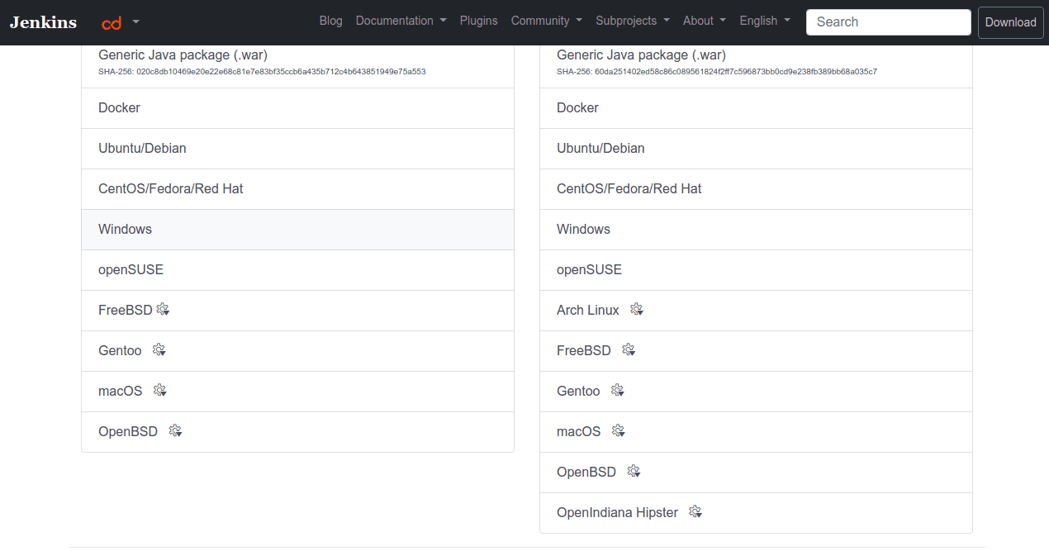
– Scroll down and click on Windows to download the latest version of the Jenkins installer on your system.
– Once the download is complete, double click on the Jenkins installation file to start the installation. You should see the Jenkins welcome page.
– Click on the Next button. You should see the Jenkins installation folder selection page
– Choose your installation folder and click on the Next button. You should see the Jenkins service credentials page.
– Select “Run service as LocalSystem” and click on the Next button. You should see the Jenkins port selection page.
– Define your Jenkins port and click on the Test Port button to test the port.
– Click on the Next button. You should see the Java path selection page.
– Define your Java path and click on the Next button. You should see the Jenkins custom setup page.
– Click on the Next button.
– Click on the Install button to start the installation.
– Click on the Finish button to complete the installation.
– At this point, Jenkins is installed on your system. Now, you will need to perform the Jenkins web based installation. Follow the below steps to perform the Jenkins web based installation.
– Open your web browser and type the URL http://localhost:8080. You should see the Jenkins initial setup screen.
– Navigate to the location on your system specified by the Unblock Jenkins page.
– Open the initialAdminPassword file using a text editor such as Notepad
– Copy the password from the initialAdminPassword file and paste the password in the Administrator password field on the Unblock Jenkins page and click Continue to proceed.
– Click the Install suggested plugins button to install the most frequently used plugins. After Jenkins finishes installing the plugins, you should see the Create First Admin User page.
– Provide your admin username, password, email and click on the Save and Continue button. You should see the Jenkins instance configuration page.
– Define your Jenkins URL and click on the Save and Finish button.
– Click on the Start using Jenkins button. You will be redirected to the Jenkins dashboard:

